**Control Statements Using If-Else Conditionals & Logic**

**If-Else Statements:**

These are used as conditional statements.

If path is straight, then move straight else turn.

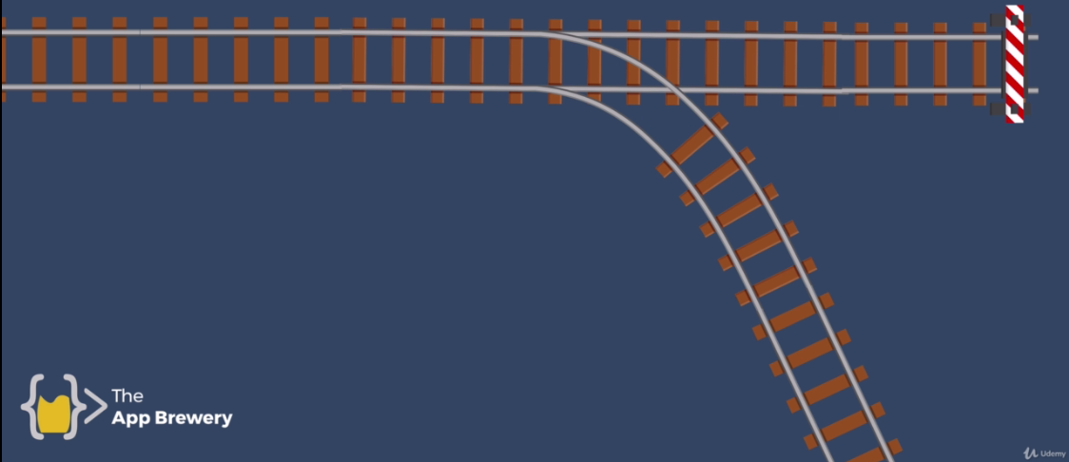

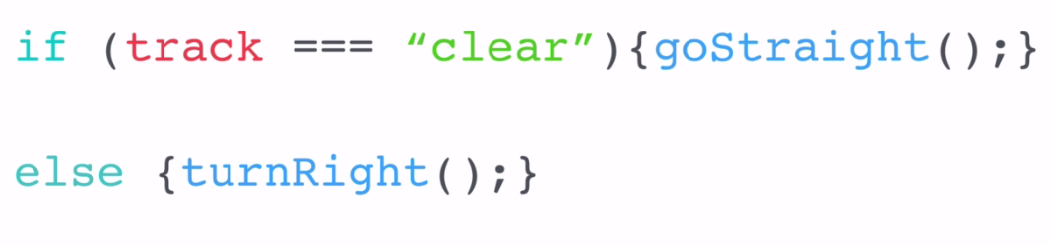

Let’s give it structure.

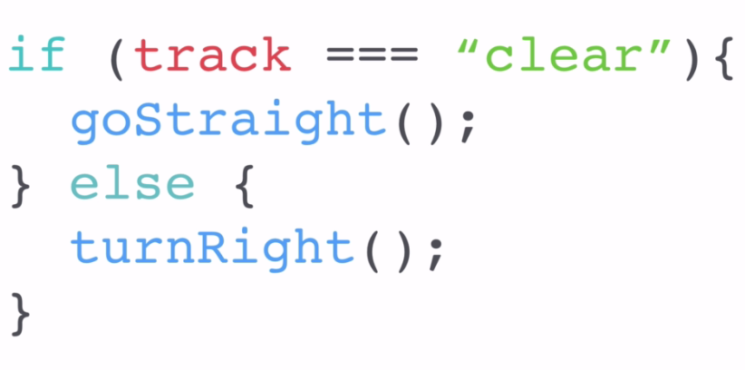

prompt("What is your name?");

prompt("What is their name?");

var loveScore = Math.random()*100;

loveScore = Math.floor(loveScore)+1; //1-100

if(loveScore===100){

alert("Your love score is: "+loveScore+"%. You love each other like Kanye loves Kanye");

}

else{

alert("Your love score is: "+loveScore+"%");

}

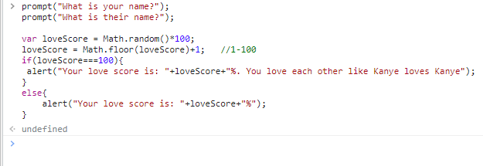

prompt("What is your name?");

prompt("What is their name?");

var loveScore = Math.random()*100;

loveScore = Math.floor(loveScore)+1; //1-100

if(loveScore>70){

alert("Your love score is: "+loveScore+"%. You love each other like Kanye loves Kanye");

}

else{

alert("Your love score is: "+loveScore+"%");

}

